Brief

The purpose of this project is to create the structure for a physics equation calculator. This webpage will contain multiple equations that are commonly encountered in physics. For example, the equations that will be included will be basic kinematic equations (velocity as a function of time, displacement as a function of time, velocity as a function of displacement, and displacement as a function velocity and time).

In addition to physics equations that will provided by default, there will be the capability to add equations to the webpage. The reason behind this is so the user can keep all of their equation in one convenient place.

The problem that this project addresses is one of my own. I often enter the same expressions into my calculator when working on physics homework. I am to the point where I have memorized the formulas and I would like to be able to easily enter the number and for the webpage to return a result.

The value of my website isn’t much for the average person but some of the peers in my physics class may find it useful. Additionally, this project will be a significant contribution to my resume once completed. To make my webpage as efficient as possible I will review the other equation websites and apply the desirable qualities of those sites to my project while also eliminating the bad qualities.

The content for the website will all be new. This includes images, color schemes, and all of the code.

Conceptual Global Site Map

Physics Equation Home

About Us

Physics Equations

Register

Wireframe

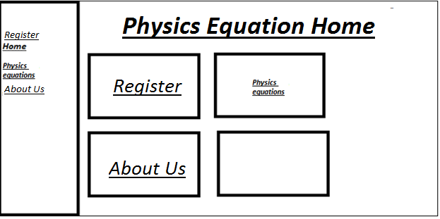

Color Scheme

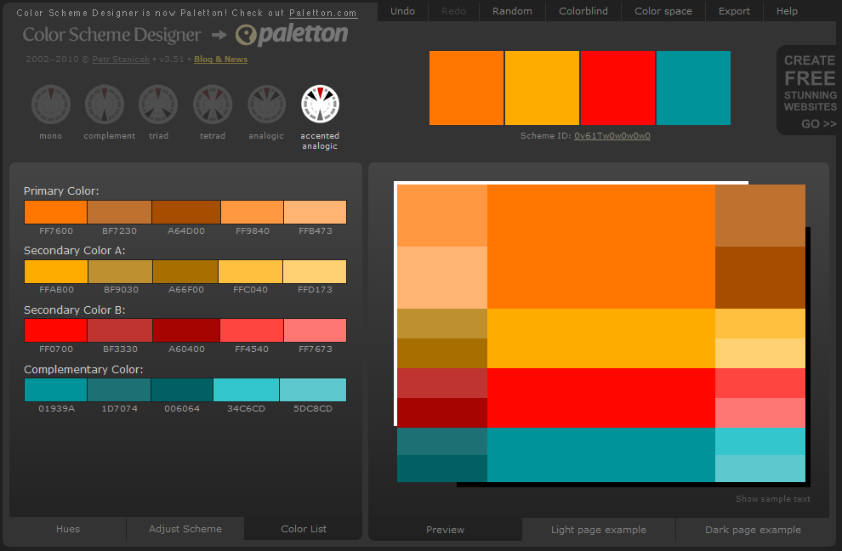

Logo:



Database

The database design will consist of three tables. One table will consist of registration information. The second table will consist of default physics equations. The third table will consist of equations the user adds to the webpage.

The first table will be used to store registration information such as login id, user password, account number, and email address. This information will be stored in the fields of the database. The primary key for every entry will correspond to the account number. The account number will be an integer that will be out incremented. The login id, user password, and account number will all correspond to text strings what will be stored as additional information.

|  |  |  |  |
| --- | --- | --- | --- |
| **Account Number** | **User ID** | **User Password** | **User Email Address** |
| 1 | joeJim | someString | [joeJim23@gmail.com](mailto:joeJim23@gmail.com) |
| 2 | jimJoe | FastTouch | [jimFoeJoe3003@gmail.com](mailto:jimFoeJoe3003@gmail.com) |

The second table will be used to store physics equations. An entry of this database will consist of a primary, auto incremented, key that will correspond to an equation number. Within the same entry there will be an equation field that will contain the equation as a string. Finally, there will be a slight explanation of the equation itself and the relevant variables that will be stored in the information column. The info column will be stored as a string.

|  |  |  |
| --- | --- | --- |
| Equation Number | Equation | Information |
| 1 | V=V0 + a(∆t) | Initial and final velocity. \n Acceleration. \n  Change in time. |
| … | …. | … |
| … | …. | … |

The third table will be used to store physics equations. Very similar to the second table, this third table is reserved to hold user input equations. An entry of this database will consist of a primary, auto incremented, key that will correspond to an equation number. Within the same entry there will be an equation field that will contain the equation as a string. Finally, there will be a slight explanation of the equation itself and the relevant variables that will be stored in the information column. The info column will be stored as a string.

|  |  |  |
| --- | --- | --- |
| Equation Number | Equation | Information |
| 1 | $$\frac{-b±\sqrt{b^{2}-4ac}}{2a}$$ | Quadratic formula derived from the Pythagorean theorem. |
| … | … | … |
| … | … | … |

References

<http://www.thebestdesigns.com/>

<http://www.awwwards.com/websites/clean/>

<http://shortiedesigns.com/2014/03/10-top-principles-effective-web-design/>

<http://webdesign.about.com/od/webdesignbasics/tp/aa112497.htm>

<http://design.tutsplus.com/tutorials/9-essential-principles-for-good-web-design--psd-56>